Exercises with drawing – Unit 4.0
These exercises are designed to increase familiarity with using pygame to draw basic graphics.
- pygame template developed in class
- draw.line, draw.rect, draw.circle
- RGB Colours

Create the following Python programs:
1. Draw a pattern of lines from the center of the screen to every 10th pixel on the perimeter of the screen. save as drawEx1.py

2. Use graph paper to draw a scene (e.g. your house.) Determine which python shapes you would need to draw this on the computer and write the important coordinates on the paper. Create a program that draws your scene in python save as drawEx2.py

3. Create a program that draws an attractive black and white chess board. save as drawEx3.py
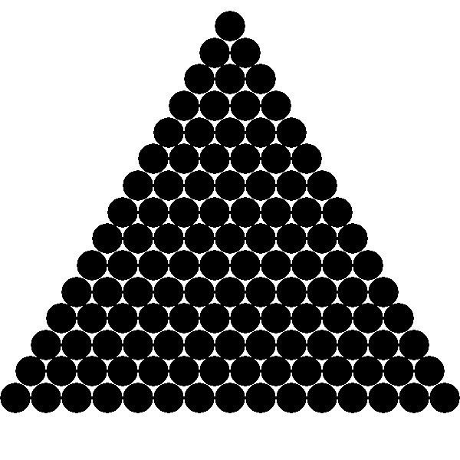
4. Create a program that draws a simple 2-d pyramid of circles on the screen. The base should have 15 circles and yes this involves some math. This question is fairly hard. I expect you to plan it out on paper first.
save as drawEx4.py

5. Create a program that draws 100, 20 x 20 rectangles at random positions on the screen.
save as drawEx5.py

6. Create a program that draws 1000 filled circles of radius 3 at random positions within 200 pixels of the center of the screen. Also randomly determine the colour of each circle separately.
save as drawEx6.py

7. Draw two randomly placed radius 10 circles on the screen then draw radius 2 circles every twenty pixels from the center of one to the center of the other. save as drawEx7.py

